Read each of the possible research questions listed below. Which perspective is being used in each case?

Functional = What purpose (s) does something serve in/for society

Conflict = what conflict is involved in/related to the social phenomena being observed. What competition is involved?

Interactionist = in what ways do people interact with each other in a social situation? What rules do they follow?

EXAMPLE: In American high schools. how do students from different social classes get along with each other? INTERACTIONIST

1. What hand signs and other symbols do gang members use to communicate with
each other? ____________________


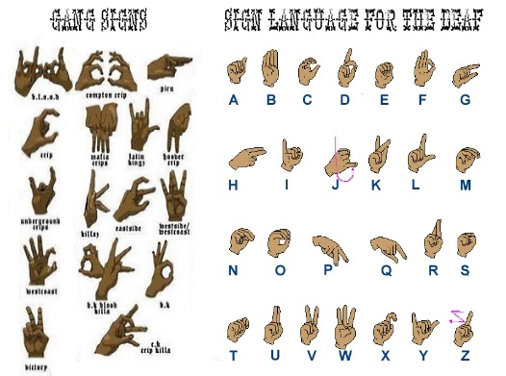

2. How has the issue of abortion polarized (separated) certain groups in American
society? ____________________



3. How has the Internet changed the ways that American live and work?
________________________

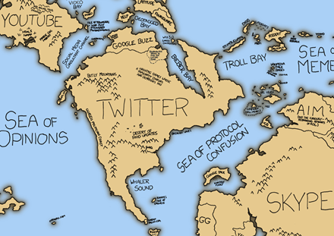

4. Does the U.S. prison system help to make criminals honest citizens or does it make
them worse criminals? ___________________



5. Why are many American opposed to President Obama's Affordable Health Care Act?
________________________



6. What are some of the adjustment problems faced by new students in American High
Schools? ____________________________



7. How does government protect the rights of American citizens? ______________

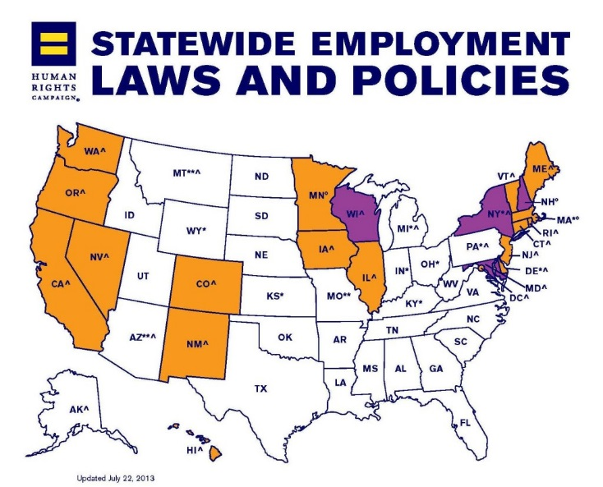

8. What are some of the rules and procedures followed by students who work together
to complete a class project? ______________________

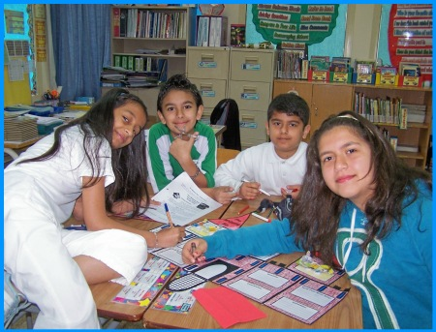

9. How do most American people react/behave when they encounter a homeless person on the streets of Chicago? ____________________

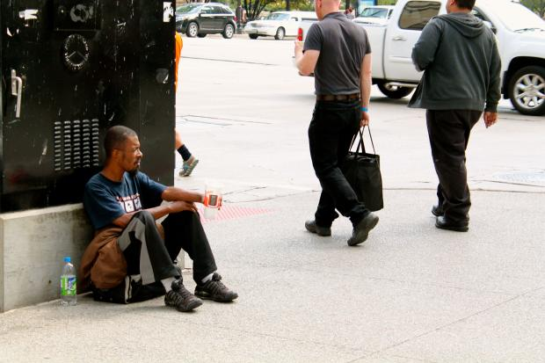

10. What kinds of problems result when there are large numbers of poor people living
in a country? __________________________

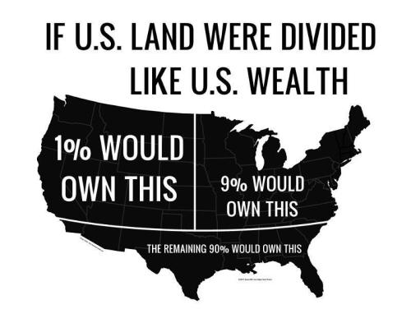

ANSWERS
(1) Interactionist - communication is necessary part of any social interaction.

(2) Conflict - any issue that separates people will typically result in conflict.

(3) Functionalist - What is the function of the Internet? What does it DO for
Americans?

(4) Functionalist - what is the purpose of the prison system and how well does it achieve its intended purpose?

(5) Conflict - there has been a lot of debate over this issue. Why do people on both sides feel the way they do about abortion? What do they think of those who hold opposite views on the issue?

(6) Interactionist - how do new student interact with teachers, students, and others in
their new surroundings. There may be some conflict involved as well.

(7) Functionalist - how well does a state or local government protect the rights of ordinary people?

(8) Interactionist - how do the students decide who is going to do what? Who becomes the leader of the group and how?

(9) Interactionist - how do the people interact with the homeless? Do they ignore them? Do they give them money?

(10) Conflict - the "have's" and "have nots" are often in conflict with each other in a
society - directly or indirectly.

```````

